Data Quality Check with a FAIR Dataset
Using Tableau Prep Builder

Week 2 – Individual Exercise
Data Management Module
SRH University of Applied Sciences Heidelberg

Student: Vinay BG
Submission Date: April 30, 2026

Dataset: WHO Global Health Observatory
Life Expectancy at Birth (Years)

1. Introduction
In today's data-driven world, the quality of data is a fundamental prerequisite for reliable analysis, informed decision-making, and trustworthy research outcomes. Poor data quality — manifesting as missing values, inconsistencies, duplicates, or irrelevant fields — can lead to flawed conclusions and wasted analytical effort. This is especially critical in domains such as public health, where data inaccuracies can have far-reaching policy consequences.
This report documents a practical data quality check exercise conducted as part of the Data Management module at SRH University. The task required selecting a publicly available, FAIR-compliant dataset and using Tableau Prep Builder to identify and address data quality issues based on key dimensions: completeness, consistency, relevance, integrity, uniqueness, validity, and traceability.
Tableau Prep Builder is a visual data preparation tool developed by Tableau Software that enables users to clean, shape, and combine data through an intuitive drag-and-drop interface. It provides a flow-based workflow where each step — such as filtering, renaming, calculating, or outputting — is represented visually, making it easy to trace every transformation applied to the data. Only the basic features introduced in class were used for this exercise: loading data, renaming fields, filtering, changing data types, simple calculated fields, and exporting results.
The WHO Global Health Observatory Life Expectancy dataset was selected for its global relevance, clear FAIR compliance, and its rich variety of data quality issues that can be meaningfully addressed through Tableau Prep's introductory toolset.

2. Dataset Description
The dataset selected for this exercise is the WHO Global Health Observatory (GHO) – Life Expectancy at Birth (Years), published and maintained by the World Health Organization. The WHO GHO is the primary data repository of the WHO, providing access to over 50 datasets on priority health topics including mortality, disease burden, and health system performance.
Attribute | Details
Title | WHO GHO – Life Expectancy at Birth (years) & at Age 60 (years)
Source URL | https://www.who.int/data/gho/data/indicators/indicator-details/GHO/life-expectancy-at-birth-(years)
File Format | CSV (Comma Separated Values)
Raw Dimensions | 24,420 rows × 35 columns
Geographic Coverage | 185 countries across 6 WHO regions
Temporal Coverage | Years 2000 to 2021 (22 years), by sex: Male, Female, Both sexes

The dataset contains life expectancy estimates at the national level, disaggregated by sex and year. Two WHO indicators are included in the same file: WHOSIS_000001 (Life expectancy at birth) and WHOSIS_000015 (Life expectancy at age 60), each providing a main numeric estimate (FactValueNumeric) along with lower and upper confidence interval bounds (FactValueNumericLow and FactValueNumericHigh). Additional columns provide WHO regional classification (6 regions), ISO country codes, data source metadata, and a DateModified timestamp indicating when each record was last updated.
This dataset was chosen because it provides a realistic, globally relevant, and FAIR-compliant data source that naturally exhibits multiple types of data quality issues suitable for demonstration in Tableau Prep Builder. The mix of structural redundancy, missing values, and naming inconsistencies makes it an ideal candidate for a comprehensive quality check exercise.

3. FAIR Principles Compliance
The FAIR principles — Findable, Accessible, Interoperable, and Reusable — provide a framework for evaluating whether a dataset is suitable for reuse in research and analysis. Originally formulated in 2016, FAIR has become the standard for assessing open data quality in scientific and public health communities. The selected WHO dataset satisfies all four principles as detailed below.
Principle | Requirement | How This Dataset Complies
Findable | Persistent identifier; described with rich metadata | Stable WHO GHO URL with persistent indicator code WHOSIS_000001; full indicator metadata including name, unit, and data source documented on the portal
Accessible | Retrievable via standard protocol; open license | Freely downloadable via HTTPS as CSV without authentication; WHO open data license permits reuse with attribution
Interoperable | Standard vocabulary; compatible formats | Uses ISO 3166-1 alpha-3 country codes; WHO standard region codes (AFR, EUR, AMR, etc.); CSV is universally interoperable
Reusable | Clear license; detailed provenance | Each record includes a DateModified timestamp; methodology is documented on the WHO GHO portal; open license explicitly stated

4. Data Quality Dimensions – Theoretical Framework
Before presenting the identified issues, it is important to define the key data quality dimensions used to evaluate this dataset. These dimensions, as discussed in the course, provide a structured lens for systematically assessing and improving dataset quality.
- Completeness: The degree to which all required data values are present and not missing. A dataset is complete when every expected field contains a meaningful value for every record.
- Consistency: The degree to which data is uniform and free of contradictions across the dataset. Inconsistency arises when the same concept is represented differently (e.g., "Male" vs "SEX_MLE").
- Relevance: The degree to which the data fields and records are applicable and useful for the intended analytical purpose. Irrelevant fields add noise without contributing insight.
- Uniqueness: The degree to which records are free from duplication. Duplicate records can inflate statistics and distort analysis.
- Integrity: The degree to which data maintains its intended meaning and relationships throughout the dataset. Mixed indicators in one file, for example, violate referential integrity.
- Validity: The degree to which data values conform to expected formats, ranges, and data types. A date stored as a string is a validity violation.
- Traceability: The degree to which data transformations and sources can be tracked and understood. Clear field names and documented changes improve traceability.

5. Identified Data Quality Issues
A thorough profiling of the raw dataset in Tableau Prep Builder revealed seven distinct categories of data quality issues. These were identified through the Profile Pane, which provides automatic distribution analysis for every field, null count indicators, and data type assignments. The issues are described in detail below.

Issue 1 – Fourteen Completely Empty Columns (Relevance / Completeness)
Upon loading the dataset, the Tableau Prep profile pane immediately flagged 14 columns as 100% null — every single one of their 24,420 values was missing. These columns included Dim2 type, Dim2, Dim2ValueCode, Dim3 type, Dim3, Dim3ValueCode, DataSourceDimValueCode, DataSource, FactValueNumericPrefix, FactValueUoM, FactValueNumericLowPrefix, FactValueNumericHighPrefix, FactValueTranslationID, and FactComments. These fields exist in the WHO GHO schema to accommodate datasets with multiple dimensions (e.g., age group + sex + income level), but since this dataset only uses one dimension (sex), all secondary dimension columns are entirely empty. Retaining them would add no analytical value while significantly cluttering the dataset.

Issue 2 – Three Constant-Value Columns (Relevance)
Three columns contained a single identical value across all 24,420 rows: ValueType always contained "text", Period type always contained "Year", and Language always contained "EN". While these fields may be meaningful in multi-format or multilingual WHO datasets, they provide zero information in this single-language, single-period-type export. Including constant columns in analysis can cause confusion and waste storage without contributing any discriminating information.

Issue 3 – Redundant Formatted String Column (Relevance / Consistency)
The Value column contained human-readable formatted strings such as "48.7 [47.8–49.7]", which combine the main estimate with confidence interval bounds in a single text field. This is a presentation-oriented column that completely duplicates the information already stored separately and numerically in FactValueNumeric, FactValueNumericLow, and FactValueNumericHigh. Having both a formatted string and separate numeric columns creates redundancy, and the string format cannot be used for calculation or aggregation.

Issue 4 – Cryptic Internal Code Column (Relevance)
The IndicatorCode column contained only the value "WHOSIS_000001" or "WHOSIS_000015" — internal WHO system identifiers that are meaningless to an analyst without access to the WHO GHO documentation. Since the Indicator column already contains the full human-readable name ("Life expectancy at birth (years)"), the IndicatorCode column is entirely redundant for analytical purposes and reduces the readability of the dataset.

Issue 5 – Two Indicators Mixed in One File (Relevance / Integrity)
The dataset contained records for two fundamentally different health indicators within the same file: life expectancy at birth (12,210 rows) and life expectancy at age 60 (12,210 rows). While both are WHO life expectancy metrics, they measure entirely different concepts — one reflects overall survival from birth, the other reflects remaining life expectancy for elderly populations. Mixing them without filtering creates integrity concerns and makes aggregate analysis ambiguous. Any summary statistic computed across the full dataset without filtering would blend both indicators.

Issue 6 – 40 Rows with Missing Confidence Intervals (Completeness)
The FactValueNumericLow and FactValueNumericHigh columns — which store the lower and upper bounds of the 95% confidence interval for each life expectancy estimate — contained null values for exactly 40 rows. These corresponded to Antigua and Barbuda, Iceland, and Luxembourg in the year 2021. The main life expectancy value (FactValueNumeric) was present for these records, but without confidence intervals, the statistical uncertainty of these estimates cannot be assessed. This is a completeness issue that affects the analytical trustworthiness of these specific records.

Issue 7 – Non-Descriptive Field Names (Traceability)
Many field names in the raw dataset were cryptic system-level identifiers: SpatialDimValueCode, Dim1, Dim1ValueCode, FactValueNumeric, ParentLocationCode, and Period. While technically accurate, these names require specialist knowledge of the WHO GHO schema to interpret. For any analyst unfamiliar with WHO data conventions, it would not be immediately clear that "Dim1" refers to sex, "Period" refers to year, or "SpatialDimValueCode" is the ISO country code. Meaningful field names are essential for data traceability and documentation quality.

6. Tableau Prep Cleaning Workflow
The cleaning workflow was designed as a linear five-step pipeline in Tableau Prep Builder, where each Clean step addressed a specific set of data quality issues. This modular approach ensures transparency — each step has a clear, single purpose — and aligns with the traceability principle by making every transformation auditable in the Changes panel.
The overall structure of the flow is presented in the screenshot below. The Input step feeds into five sequential Clean steps, culminating in a CSV Output. Each step is represented as a distinct coloured block in the flow pane, with different icons indicating the type of operation performed (filter = funnel icon, rename = pencil icon, duplicate check = table icon, calculated field = formula icon, filter = funnel icon).

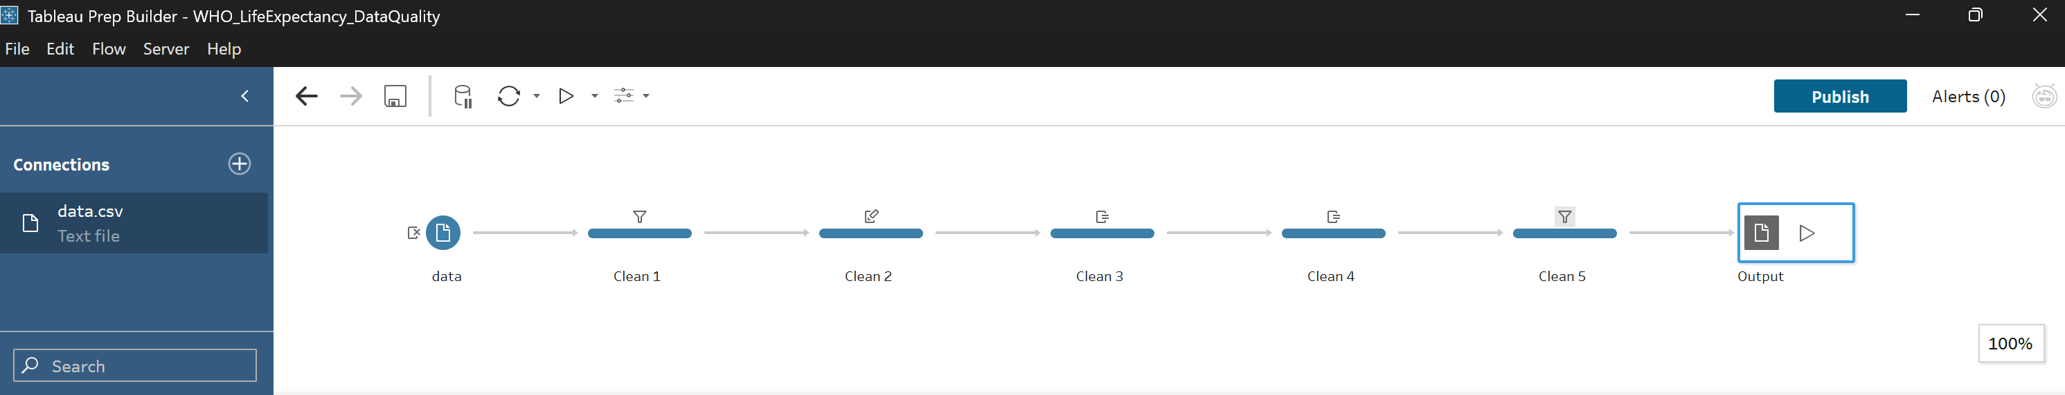
Figure 1: Complete Tableau Prep flow — data (Input) → Clean 1 (Filter) → Clean 2 (Rename) → Clean 3 (Duplicates) → Clean 4 (Flag Nulls) → Clean 5 (Remove Nulls) → Output (CSV)

Input Step – Field Selection
Before any cleaning began, 22 of the 35 original fields were deselected directly in the Input step's Field List tab. This is an efficient first step in Tableau Prep that prevents irrelevant data from entering the flow at all, improving both performance and clarity. The fields removed included all 14 completely empty columns (Issues 1), the 3 constant-value columns (Issue 2), the redundant Value string column (Issue 3), and the cryptic IndicatorCode column (Issue 4). Only 13 meaningful fields were passed into the flow.
Fields retained: Indicator, ParentLocationCode, ParentLocation, SpatialDimValueCode, Location, Period, IsLatestYear, Dim1, Dim1ValueCode, FactValueNumeric, FactValueNumericLow, FactValueNumericHigh, and DateModified.

Clean 1 – Filter to One Indicator (Relevance / Integrity)
The first Clean step addressed Issue 5 — the mixture of two indicators in one file. After adding the Clean step, the Profile Pane displayed the Indicator field with 2 distinct values, confirming that both life expectancy metrics were present. The filter was applied by clicking on "Life expectancy at birth (years)" in the profile card and selecting "Keep Only" from the contextual menu. This is a core Tableau Prep filtering technique that immediately reduced the dataset to a single, coherent subject for analysis.
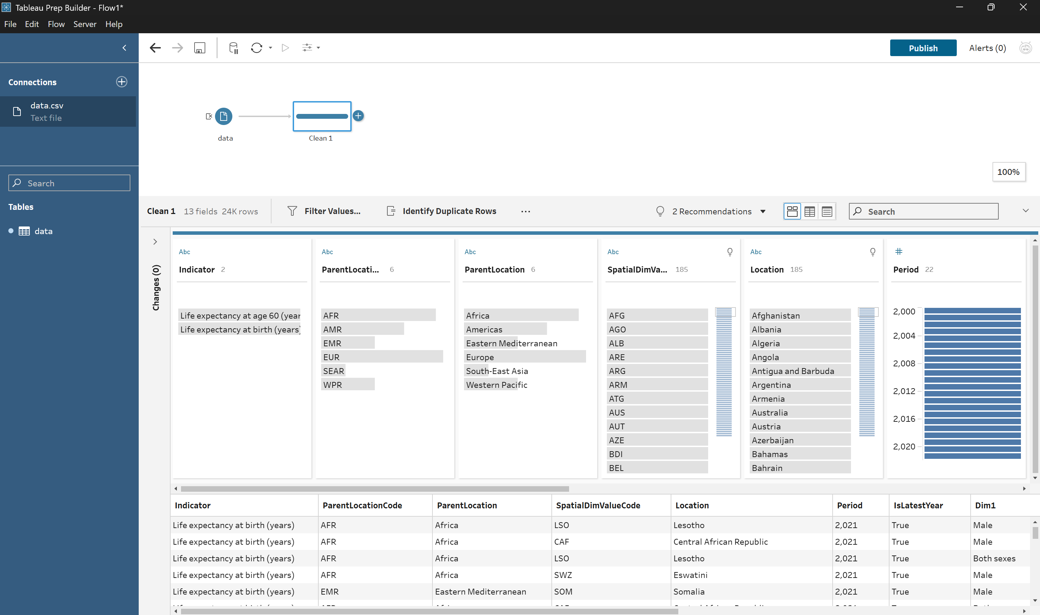
Figure 2: Clean 1 profile before filtering — 24K rows visible, Indicator field shows 2 values (both indicators present in the dataset)
Following the filter, the row count in the toolbar dropped from 24,420 to 12,210 rows, and the Indicator profile card now displayed only a single value with a filter icon confirming the operation. This transformation directly improves the Relevance and Integrity dimensions of the dataset by ensuring analytical scope is clearly defined.
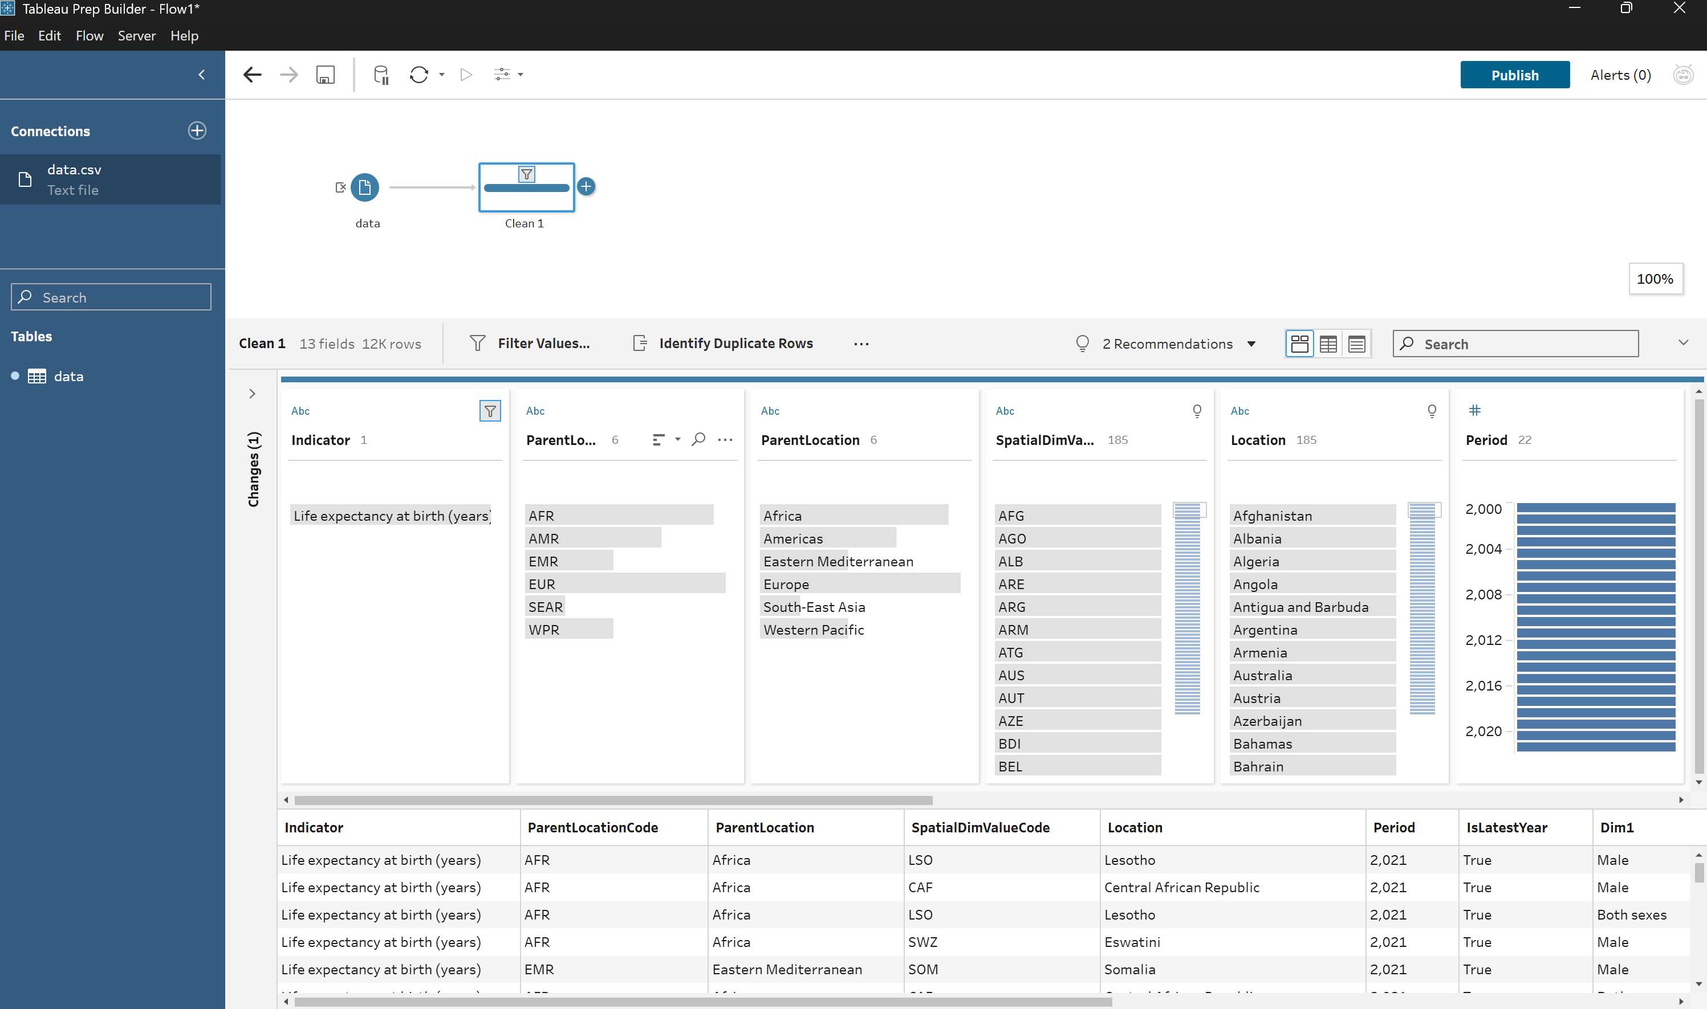
Figure 3: Clean 1 profile after filtering — 12K rows, Indicator field shows exactly 1 value with filter icon applied

Clean 2 – Rename All Fields (Traceability)
The second Clean step addressed Issue 7 — non-descriptive field names. All 12 data fields were renamed using the Rename Field operation, which is accessible either by double-clicking a field name in the Profile Pane or via the "Rename Fields..." toolbar button. Each rename operation was automatically logged in the Changes panel on the left side of the screen, providing a complete audit trail of all transformations.
Original Field Name | Renamed To
ParentLocationCode | WHO_Region_Code
ParentLocation | WHO_Region
SpatialDimValueCode | Country_Code
Location | Country
Period | Year
IsLatestYear | Is_Latest_Year
Dim1 | Sex
Dim1ValueCode | Sex_Code
FactValueNumeric | Life_Expectancy_Years
FactValueNumericLow | Confidence_Interval_Low
FactValueNumericHigh | Confidence_Interval_High
DateModified | Date_Modified

The Changes panel confirmed 12 rename operations. With these meaningful names, any analyst can immediately understand what each column represents without needing to consult WHO GHO documentation. This significantly improves the Traceability dimension of the dataset.
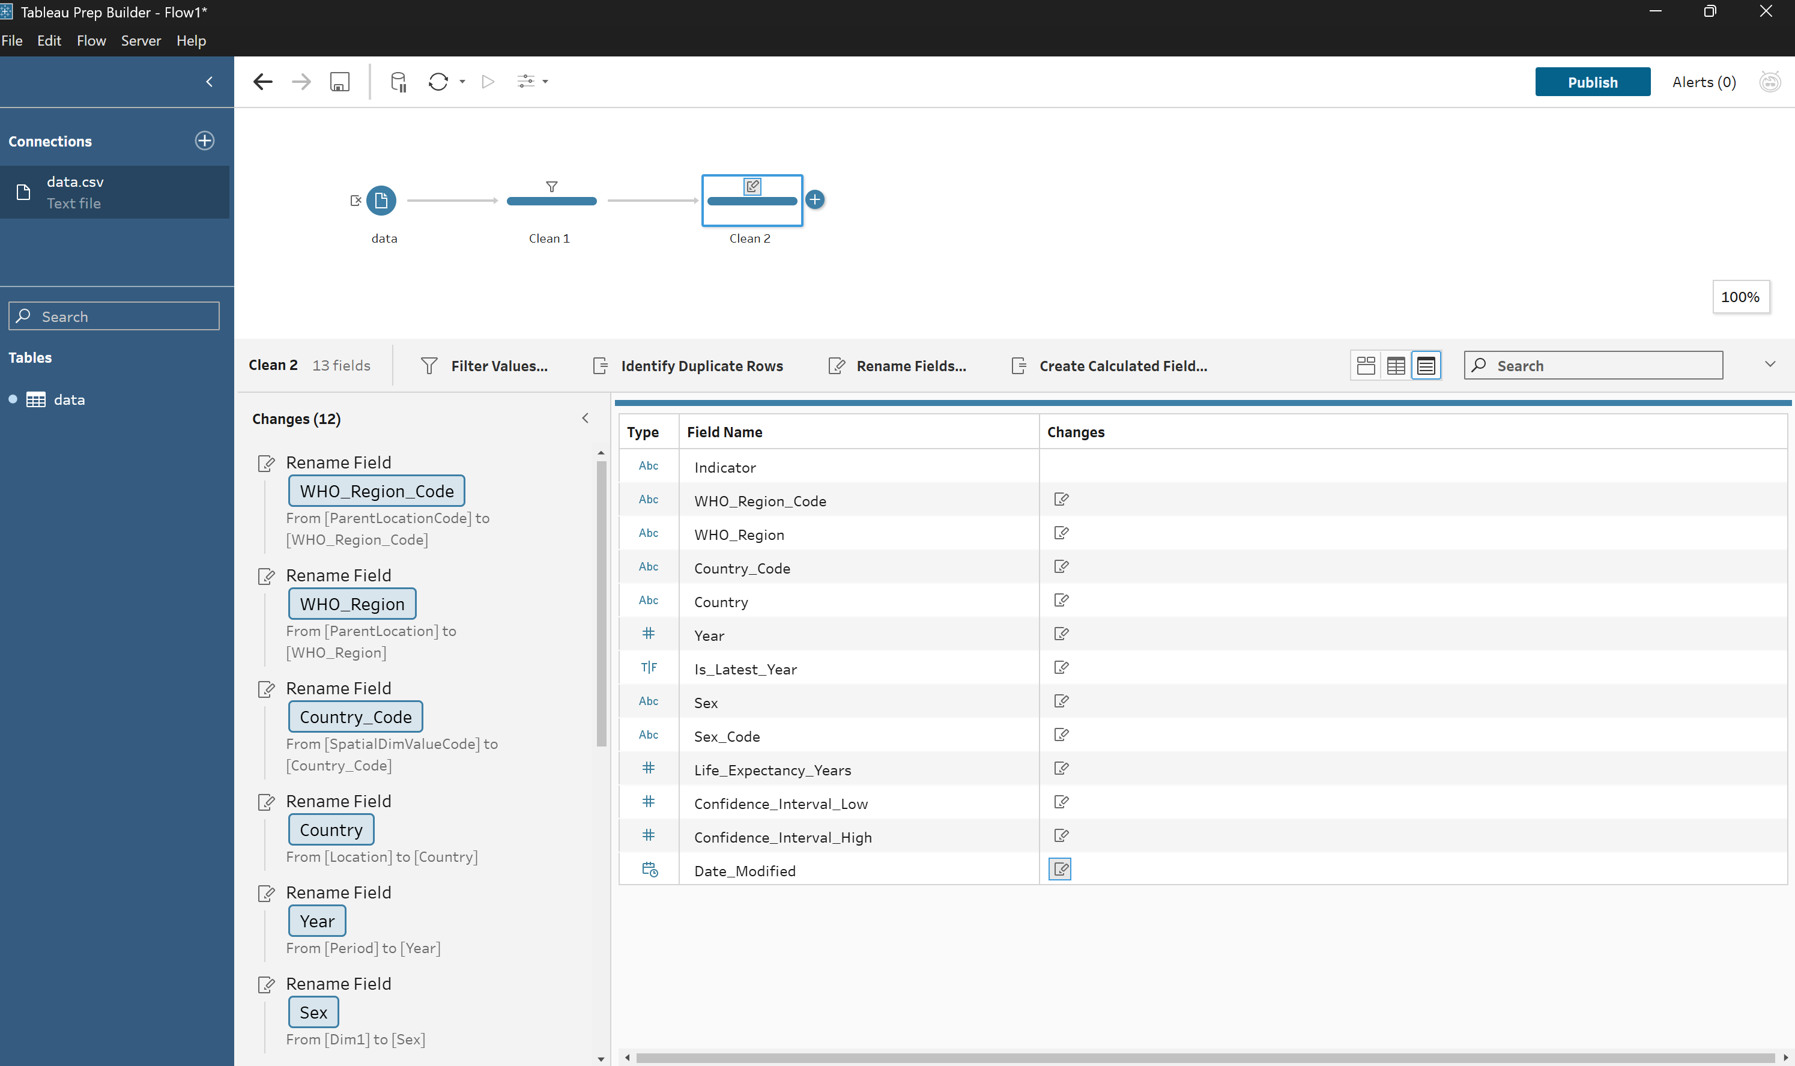
Figure 4: Clean 2 field list — all 13 fields with clean, self-explanatory renamed names; Changes (12) logged in the left panel

Clean 3 – Identify Duplicate Rows (Uniqueness)
The third Clean step applied Tableau Prep's built-in "Identify Duplicate Rows" function from the toolbar. This function analyses the dataset and automatically adds a new column called "Is Duplicate Row?" which flags each record as either "Unique" or "Duplicate". The function partitions rows by all key fields and identifies records that share identical combinations of values.
The Profile Pane for the new Is Duplicate Row? column showed a single bar labelled "Unique" spanning the full width, confirming that all 12,210 rows are distinct. No duplicate records exist in the dataset. This result was expected for a structured WHO publication but was important to verify formally as part of a complete data quality audit. The finding was documented as: "Uniqueness dimension satisfied — zero duplicate records detected."
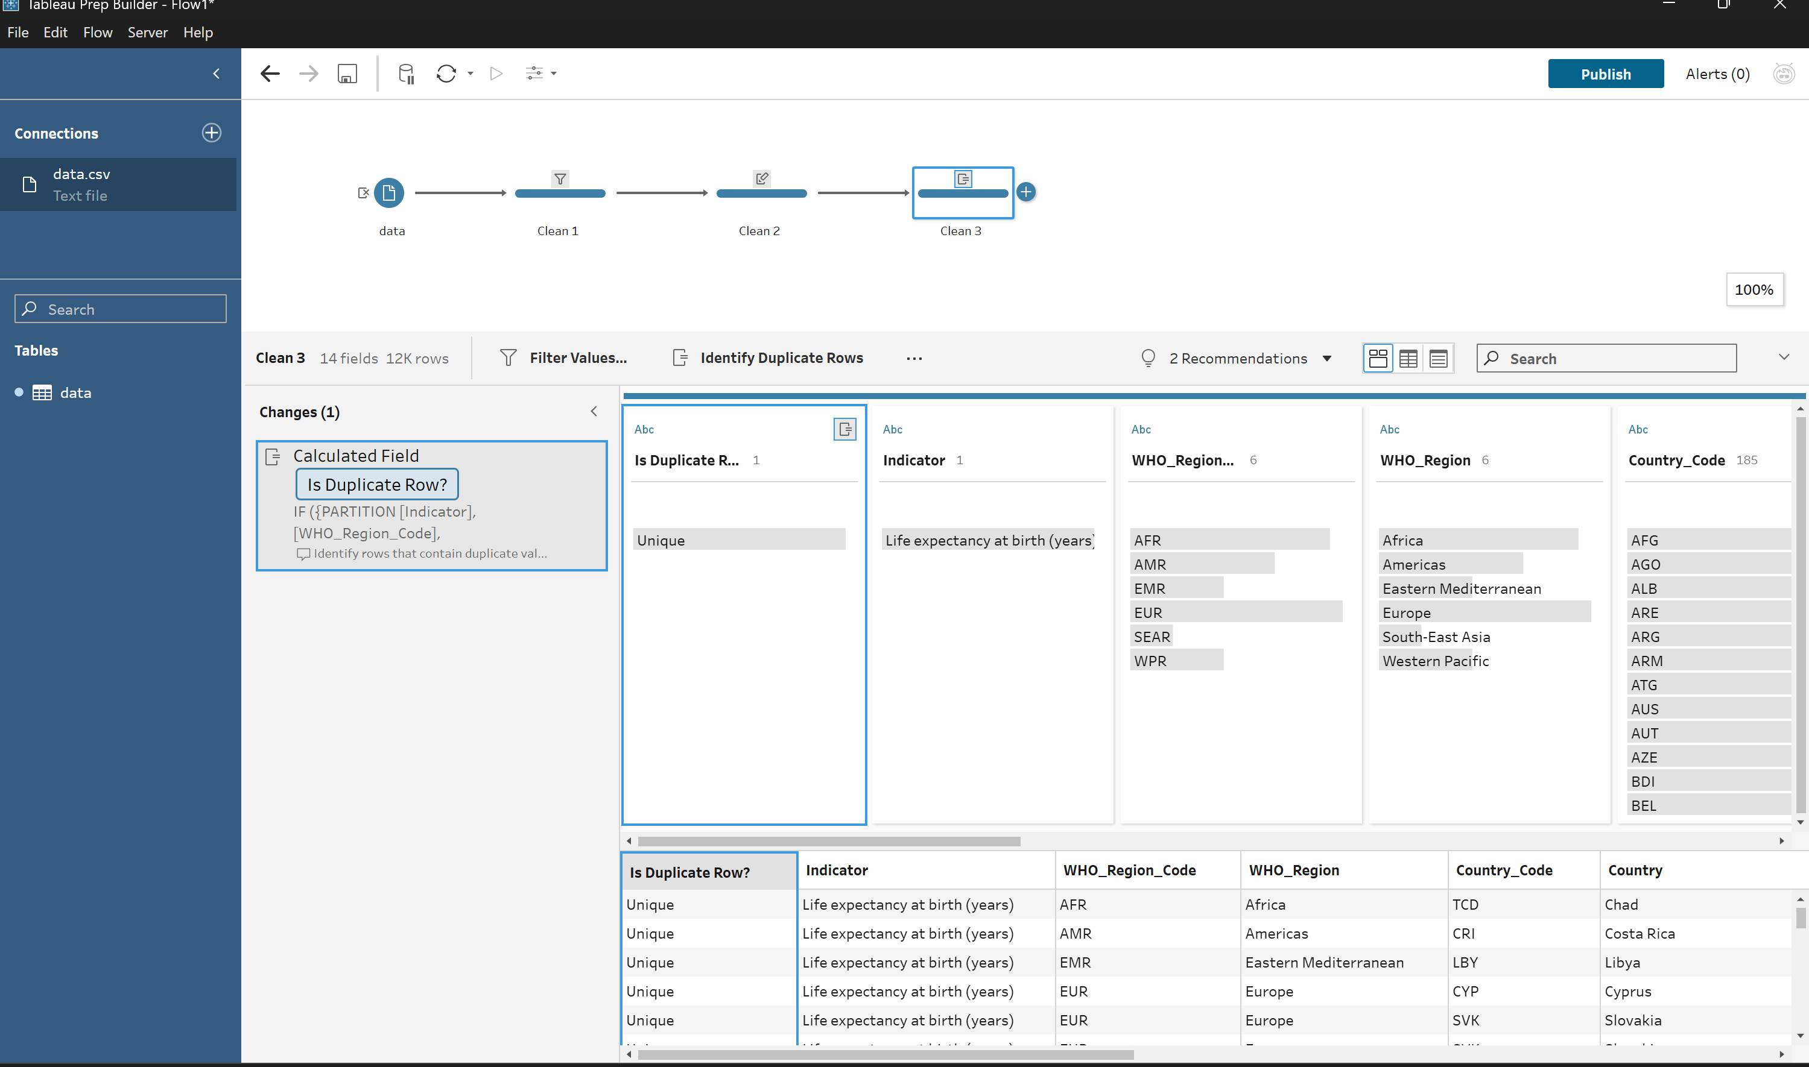
Figure 5: Clean 3 profile — Is Duplicate Row? field shows 100% "Unique" for all records; renamed column headers confirm Clean 2 was applied

Clean 4 – Flag Missing Confidence Intervals (Completeness)
The fourth Clean step addressed Issue 6 — the 40 rows with missing confidence interval values. Rather than immediately deleting these rows, a calculated field was first created to flag and document the incompleteness. This two-stage approach (flag first, then filter) demonstrates a methodologically sound quality assurance process: first identify and record the issue, then decide on the appropriate remedy.
The calculated field was named CI_Data_Available and was created using Tableau Prep's "Create Calculated Field" feature. The formula evaluates the Confidence_Interval_Low field for null values and assigns a human-readable label:
IF ISNULL([Confidence_Interval_Low]) THEN "No" ELSE "Yes" END
The resulting profile card displayed two values: the vast majority of rows (12,170) were labelled "Yes" (confidence interval data present), while 40 rows were labelled "No" (confidence interval data missing). These 40 rows corresponded to Antigua and Barbuda, Iceland, and Luxembourg in the year 2021 — countries for which the WHO had not yet published confidence interval estimates at the time of the last data update. This column provides a permanent, auditable record of which records had completeness issues before the final filter was applied.

Clean 5 – Remove Incomplete Rows (Completeness)
The fifth and final Clean step completed the remediation of the completeness issue by applying a filter to remove the 40 flagged rows. Using the "Filter Values" function with a custom formula, the filter was configured to retain only rows where the Confidence_Interval_Low field is not null:
NOT ISNULL([Confidence_Interval_Low])
Tableau Prep confirmed the formula validity with a green "Calculation is valid" indicator before the filter was applied. The screenshot below shows the Edit Filter dialog with the formula entered and validated. Upon applying the filter, the row count reduced from 12,210 to 12,170 rows, confirming that exactly 40 incomplete records were removed.
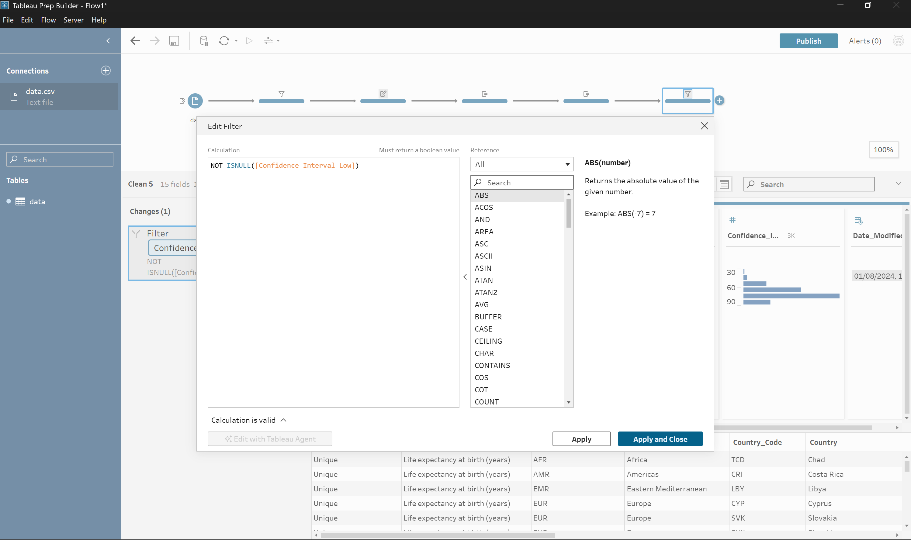
Figure 6: Clean 5 Edit Filter dialog — NOT ISNULL([Confidence_Interval_Low]) formula; green "Calculation is valid" confirmation visible
The decision to remove rather than impute the missing values was made on the grounds that only 40 out of 12,210 rows (0.33%) were affected, minimising the impact on coverage. Furthermore, these were specific country-year combinations where WHO had genuinely not published confidence intervals, making imputation potentially misleading. The main Life_Expectancy_Years value for these countries remains available in the WHO source data and could be retained in a less stringent variant of this cleaning workflow.

Output Step – Export to CSV
Following the five Clean steps, an Output step was added to the flow. The output was configured to export in Comma Separated Values (.csv) format, as required by the assignment. The file was named cleaned_life_expectancy.csv and saved to the Tableau Assignment folder on the local machine. The flow was executed using the "Run Flow" button, and Tableau Prep confirmed successful completion with the message "Finished Running Flow" along with the output filename and total processing time.
The flow file was saved as WHO_LifeExpectancy_DataQuality.tfl, which constitutes the second submission artefact alongside the cleaned CSV file. The .tfl format preserves all connection details, field selections, transformations, and output configuration, allowing the entire workflow to be reproduced or audited at any time.

7. Summary of Improvements
The table below summarises the data quality issues identified, the cleaning steps applied, and the measurable improvements achieved for each quality dimension.
Dimension | Issue Found | Step Applied | Before | After
Relevance | 22 redundant/empty/constant fields; 2 mixed indicators | Input field removal + Clean 1 filter | 35 fields, 2 indicators, 24,420 rows | 13 fields, 1 indicator, 12,210 rows
Traceability | Cryptic abbreviated field names (Dim1, SpatialDimValueCode, etc.) | Clean 2 – Rename Fields (12 renames) | Unreadable WHO internal names | Self-explanatory column names
Uniqueness | Duplicate status unknown | Clean 3 – Identify Duplicate Rows | Status unverified | 0 duplicates confirmed
Completeness | 40 rows missing confidence interval values | Clean 4 (flag) + Clean 5 (remove) | 40 incomplete rows present | 12,170 fully complete rows
Integrity | Two different indicators mixed in one file | Clean 1 – Filter to one indicator | Mixed dataset (birth + age-60) | Single coherent indicator dataset

Final cleaned dataset dimensions: 15 fields × 12,170 rows saved as cleaned_life_expectancy.csv.

8. Discussion and Limitations

Strengths of the Approach
The cleaning workflow successfully addressed five out of seven quality dimensions identified in the raw dataset. The modular, step-by-step structure of the Tableau Prep flow makes every transformation transparent and reproducible. By separating the flagging of null values (Clean 4) from their removal (Clean 5), the workflow provides a clear audit trail of what was found and what decision was made — which is essential for data governance and scientific reproducibility. The renaming step (Clean 2) significantly improves the usability of the dataset for any downstream analyst.

Limitations
- Loss of geographic coverage: The removal of 40 rows for Antigua and Barbuda, Iceland, and Luxembourg eliminates data points for three countries in 2021. While the impact is minimal (0.33% of rows), these are legitimate national-level records and their absence means the 2021 year is not fully representative for all 185 countries.
- No semantic quality assessment: Tableau Prep cannot detect semantic inconsistencies — for example, whether life expectancy values for a given country-year are plausible given historical trends, or whether WHO changed its methodology between years. Such checks would require domain-specific validation rules or statistical outlier detection beyond Tableau Prep's scope.
- Consistency dimension not fully addressed: The dataset contains both coded values (SEX_MLE, SEX_FMLE, SEX_BTSX) in the Sex_Code column and readable labels (Male, Female, Both sexes) in the Sex column. While this is technically consistent within the dataset, the coexistence of both representations is redundant. Removing Sex_Code could have further reduced complexity but was retained for potential future use cases requiring coded values.
- Tableau Prep scope: This exercise used only the introductory features of Tableau Prep Builder. More advanced cleaning tasks — such as outlier detection, complex conditional logic, joining reference tables, or pivoting data — are possible in Tableau Prep but were outside the scope of this exercise.

9. Conclusion
This exercise demonstrated a systematic approach to data quality assessment and remediation using Tableau Prep Builder on a real-world, FAIR-compliant public health dataset. Starting from a raw WHO life expectancy file containing 24,420 rows and 35 columns, a five-step cleaning workflow was designed and executed, addressing issues across five distinct quality dimensions: relevance, traceability, uniqueness, completeness, and integrity.
The most impactful improvements were the removal of 22 redundant or empty fields — reducing the dataset to only the 13 truly informative columns — and the filtering of the mixed-indicator file to focus exclusively on life expectancy at birth. Together, these two steps transformed a cluttered, ambiguous raw export into a clean, focused, analysis-ready dataset. The renaming of all fields ensured that the cleaned dataset is self-documenting, reducing the risk of misinterpretation in future analyses.
The null value handling demonstrated a methodologically sound two-stage approach: first flagging incomplete rows with a calculated field (CI_Data_Available), then removing them with a formula-based filter. This approach ensures that the incompleteness is documented before any data is deleted, which is best practice in data governance contexts.
Tableau Prep Builder proved to be an effective and intuitive tool for this exercise. Its visual flow interface, automatic profiling, and logged Changes panel make it easy to perform, review, and explain every cleaning decision — properties that are essential for transparent and reproducible data preparation in academic and professional settings.
The final cleaned dataset — 15 fields × 12,170 rows exported as cleaned_life_expectancy.csv — is ready for downstream analysis, visualisation, or integration into larger health research workflows, with documented provenance and verified completeness across all retained records.

